Ai hologram & digital presence (UC-01)
  - Prepared by: BA – Shaun John Stanley | Sprint 1, Week 3 | Protype Build Phase

The following is revised as per dev team notes from 7th September 2026. The following use case definition is presented before the official sprint playback scheduled for the 11th of September. This use case now reflects the live performer driven motion and voice synchronized avatar approach. The team members will present various aspects of the approach in areas such as Judy (Voice), Logan (Motion & WebSocket Server) & Patrick (Unity/model). This approach would be more feasible rather than an autonomous AI Q&A interaction as it is a perfect starting point underneath the conceptual design confirmed by Nikitha (Telstra).

1. Overview

Use Case ID | UC-01 (Revised)
Use Case Name | Voice presented in real-time with motion sync to a live-performed holographic Avatar
Primary Actor | Operator/Performer: An individual (Telstra representative) whose live voice and body motion is captured and used to drive the digital character in real time.
Secondary Actor (s) | Audience/Viewer: An individual (s) present who perceives the synced digital character as a present representative. Telstra (system owner) whose “digital presence” the performance represents.
Brief description | Body movement and live voice is captured via microphone and camera, serialiased and transcribed and then streamed in real time (via WebSocket server) into Unity, where a 3D character mirrors the performers motion (e.g., gestures and blinking) and speaks in sync with a transcribed voice. This produces a live, puppeteer digital avatar conceptually similar to VTubing/real-time motion-capture puppeteering – that an audience experiences as a present digital representative without the performer being physically in the room.
Stakeholders and Interests | Performer: wants their voice and motion responsive and reflected by the character. Audience seeking a convincing, responsive digital presence, not a laggy or static animation. Telstra: wants proof that a real person’s Prescence can be projected via Hologram without them being physically there. Project team: voice and motion sync pipeline demonstration and that is technically feasible within RMIT VX Lab hardware and budgetary constraints.
Preconditions | Microphone and camera are set up to capture the performer (video feed of the subject in the frame and voice input configured through the mic). The motion detection script (MediaPipe PoseDetector) and the voice transcription script are running. The WebSocket server (Logan) is running to relay data between the python scripts and Unity. The Unity Project is then loaded with the 3D character model (currently a stick-figure placeholder pending further 3D modelling research) and connected to the server.
Trigger | The performer begins speaking and moving within the capture zone (microphone and camera range).
Priority (MoSCoW) | Compulsory haves: The core technical proof of concept is the underpinning the “digital presence” pitch. The conceptual design has no demonstrated feasibility layer.
Frequency of Use | Continuous during the live demo session (the use case is exercised for the full duration whilst the performer is in the capture zone and not a single discrete transaction).
Current Fidelity Level | Proof of concept (POC). The full motion, stick figure placeholder model, ~30 tracked points, MediaPipe “Life” model. No confirmed AI generated response later, live transcription only. Not yet integration evaluated end to end as the following is a single continuous pipeline: Python → WebSocket → Unity

2. System Architecture and Data Flow

The following diagram traces how a single moment of performance becomes a synced digital character, and identifies which teammate owns each moment. This is furthermore used to both validate the use case’s technical plausibility and to clarify the handoffs between Judy, Patrick, and Logan.
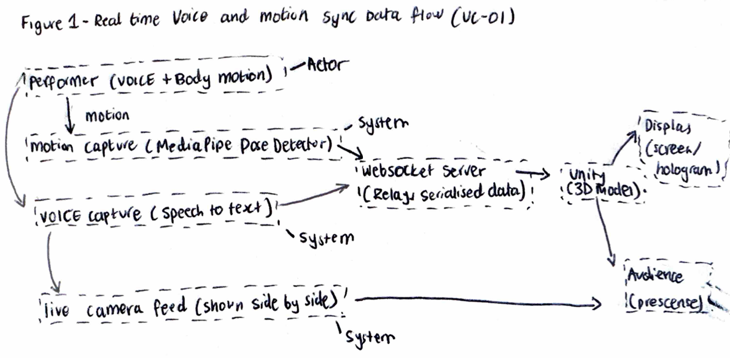
Figure 1 – Motion Sync data flow and Real time voice (UC-01). The following displays output/actors and system components.

3. Main Success Criteria

- Within the camera and microphone capture zone, the performer stands within the beginners to move and speak.
- The motion detection script (MediaPipe PoseDetector) captures the performers body points (currently ~30 tracked points) and filters to only points the model is confident exists in the current frame.
- The tracked points are seralised as Vector3 objects and sent to the WebSocket server.
- In parallel, the voice script then captures the performers’ speech and produce3s a live transcription, also sent to the server.
- The WebSocket Server continuously relayed information from the voice data and combined motion to Unity in real time.
- Unity then applies the incoming motion data to the 3D character model, so the model then mirrors the performers’ movements (e.g., when the character blinks & when the performer blinks).
- The transcribed voice output is displayed/played back coordinated with the character’s movement, showcasing the audio transcript alongside the animation.
- The performer is shown side by side with the unity scene whilst the live camera feed is also shown so the audience can directly compare the real performer to the synced digital character.
- The audience further observes the character in real time performance as a demonstration of digital presence concept.

4. Alternative Flows

- A1:

  - No holographic hardware is currently available for a given demo.
  - The Unity scene is shown through a standard screen or projection instead of a true holographic display hardware (demonstrating sync feasibility).
A2:
  - One data stream lags or errors.
  - Voice sync and motion are decoupled, so if the voice transcription fails the motion sync can still be demonstrated on its own vice versa.
A3:
  - 3D models not ready yet: the demo then proceeds with the current stick figure placeholder model, since the use case is intended to prove the sync pipeline works and this results in an independent final model of fidelity.

5. Exceptions

- E1:
  - Tracked points fall below the model’s confidence threshold (e.g. poor lighting or occlusion):
  - Low confidence points are filtered out rather than causing glitchy character movement or erratic motions.
- E2:
  - WebSocket connectivity drops.
  - Unity holds the character’s last known pose rather than defaulting to a broken or frozen mid-glitch state.
- E3:
  - Voice transcription fails or its inaudible.
  - The system either omits the audio-transcript display for that segment or flags it, rather than showing an incorrect transcript.

6. Non-Functional Requirements

These targets are not confirmed through testing due to no end-to-end latency test, and they are stated as acceptance targets, so the dev team has a concrete bar to build and evaluate against, rather than a implicit expectation.
Category | Requirement | Rationale / Target
Latency | Motion-to-render delay should be low enough that lip/gesture sync does not read as noticeably delayed to an observer. | Target: under ~200ms end-to-end (capture → WebSocket → Unity render). No formal measurement taken yet — flagged as a testing gap in Critical Analysis below.
Tracking Robustness | Motion tracking should degrade gracefully, not erratically, under non-ideal conditions (variable lighting, partial occlusion). | MediaPipe Lite model confidence filtering (existing) should be extended with smoothing/interpolation if jitter is visible in testing.
Reliability | A dropped WebSocket connection or a single failed frame should not crash the Unity scene or visibly break the character. | See Exception E2 (hold last known pose rather than fail).
Consent & Privacy | Live capture of a performer's voice and likeness must be disclosed and consented to before any demo or recording. | Directly inherited from the consent or ethics requirement raised during Sprint 1 BA validation and industry research (voice cloning caution).
Usability (Audience-facing) | An audience member with no technical background should be able to tell, within seconds, that the character is responding to the performer. | Supports the “digital presence” framing. A delayed or unclear link between performer and character undermines the core pitch to Telstra.

7. Acceptance Criteria

- AC1: When the performer moves a tracked body part, the corresponding movement is reflected visibly on the 3D character within the target latency window (NFR: Latency).
- AC2: When the performer speaks, the text transcription of their speech is then displayed within the same demo session, later synchronized closely enough that a viewer can follow along.
- AC3: The Live camera feed and the Unity-rendered character can be displayed does not visibly glitch, freeze mid-frame in a broken pose or crash the Unity Application.
- AC5: The full pipeline (Motion capture → WebSocket → Unity) has been run on a continuous cycle and there is ended to end test at least once prior to any client facing demonstration (currently outstanding).

8. Assumptions and Dependencies

- Assumes there is continued access to RMIT VX Lab hardware through the Looking glass display, capture equipment for the duration of the prototype build phase.
- Assumes Judy’s voice transcription prototype and Logan’s motion-detection prototype remain compatible in output format (both will need to be serialized to format the WebSocket Server and Unity can consume without a further translation layer.
- It depends on Patrick’s Unity side work to consume WebSocket data and drive the 3D model which is currently on the long pole, since motion and voice capture are each individually prototyped but not yet wired into Unity end to end.
- Full dependency on Shaun’s 3D modelling research to move the character beyond the current stick figure placeholder before any client facing demonstration.
- Assuming that the performer is willing to give a live demo and is briefed by the team members in addition to consenting with the Telstra representative, not a member of the public.

Postconditions and Constraints

Postcondition (Success) | The audience observes a 3D character whose motion and voice are believably visible and synced in real time to the live performer. This demonstrates the core technical feasibility of the “digital presence” concept without requiring the performer to be physically present.
Postcondition (Failure) | Sync degrades gracefully rather than breaking outright (e.g. the character holds its last known pose rather than glitching), or one data stream (voice or motion) continues even if the other one drops.
Business Rules & Constraints | Must be demonstrable on RMIT's own VX Lab hardware, not Telstra's premises or equipment. Any live camera or voice capture requires disclosed consent (no data is stored without disclosure), as per the consent/ethics requirement raised during BA validation and Sprint 1 industry research. Per Telstra's (Nikitha) confirmed scope, this use case is the technical feasibility layer underneath the conceptual design. This demonstrates how a live “digital presence” could work, not a finished, audience-facing product. Current model fidelity is a stick-figure placeholder pending further 3D modelling research (assigned to BA).
Related Precedents | Proto Hologram enterprise telepresence (closest narrative fit for “presence without being there”, Sprint 1 research). Technically, this use case is closer to VTubing / live motion-capture puppeteering than to the Kailey (Proto × Cisco).

10. Risk Register

ID | Risk | Likelihood | Impact | Mitigation
R1 | End-to-end latency (capture → WebSocket → Unity) is too high, resulting in a failed character presentation. | Medium | High | Run and time a full end-to-end test before committing to a live demo format which falls back to a pre-recorded/looped demo if latency can't be brought down in time.
R2 | MediaPipe Lite model's ~30 tracked points and current stick-figure model look unconvincing to Telstra as “digital presence,” undermining the pitch. | Medium | Medium | Frame the current build explicitly as a feasibility POC (per Fidelity Level field above) rather than the final visual bar. Shaun's 3D modelling research before any client-facing showcase is a priority.
R3 | The three components (voice, motion and Unity rendering) have each been prototyped independently by different developers but not yet integration-tested together. | High | High | Schedule a dedicated integration session before next sprint review; treat AC5 (end-to-end test) as a hard gate before any demo is booked with Nikitha.
R4 | Live capture of a performer's voice/likeness without clear consent process, especially if a non-team member ends up performing. | Low | High | Restrict performers to briefed, consenting team members (or Telstra reps) for now. This document consent explicitly per the ethics requirement already raised in Sprint 1 research.
R5 | RMIT VX Lab hardware (Looking Glass display) availability is time-limited/shared, risking a bottleneck close to a demo deadline. | Medium | Medium | Book VX Lab time in advance for integration testing and any rehearsal. In addition, have the screen-only fallback (Alternate Flow A1) ready regardless.

11. Critical Analysis and Limitations

The Use Case is best represented as a feasibility hypothesis, not a validated design. Just on a purely descriptive scenario, several elements carry real risk. First the three technical components, voice transcription, unity rendering, and motion detection. These have been prototyped in isolation by different team members (Judy, Patrick, and Logan respectively). But as a document, no one has run them together as a single continuous pipeline yet. The Main Success Scenario describes the intended integrated flow, not as a flow that has been observed to work end to end, and this is the single largest gap between what is proven and what is documented. This proves the reason the acceptance criterion AC5 and Risk R3 exists.
Secondly, the MediaPipe “Lite” PoseDetector’s ~30-point tracking and the current stick-figure placeholder model is not a stylistic choice a fidelity ceiling. There is a real risk of the demo undercutting its own pitch if Telstra’s expectation drifts from a conceptual design. Framing this explicitly to Nikitha as a POC layer beneath the conceptual design as this a deliberate mitigation not just a disclaimer.
Third, the VTuber style mimicking mechanism for this use case now describes a genuine pivot from the AI Q&A framing implied previously and cited during sprint 1 research. Even though that research remains useful evidence for the audience that an AI mediated presence in a retail Q&A context. In the previous research we can confirm citing Kailey would be the closest technical fit, without this caveat the project direction that has been taken in the current stage would still validate the research.
Finally, the nonfunctional targets in the document such as tracking robustness and latency are acceptance bars rather than measured results due to no formal timing or robustness testing conducted. In addition, Risk R3 and Criterion AC5 would still need to be evaluated against as treating them already met would be premature.

12. Glossary of Terms

Term | Definition
MediaPipe PoseDetector | Google's pose-estimation model used to detect and track points on a human body from camera input and is used here in its “Lite” (faster, lower-fidelity) configuration.
WebSocket | A network protocol that keeps a connection open for continuous two-way data transfer, used here to relay motion and voice data to Unity in real time (as opposed to one-off request/response calls).
Vector3 | A data structure representing a point in 3D space (X, Y, Z coordinates) that is used to encode each tracked body point before sending it over the network.
Unity | A game engine used here to render the 3D character model and apply incoming motion data to it.
Looking Glass (LFD) | A Light Field Display holographic-style hardware used in the RMIT VX Lab to render 3D content viewable without special glasses.
POC | Proof of Concept is a build intended to demonstrate technical feasibility, not a finished, production-ready product.
VTubing | A live-streaming practice where a performer's voice and motion drive a virtual and animated avatar in real time; used here as the closest existing analogy for this use case's mechanism.

